Fast Facts
Highlights:  Majors in Demand  - Agricultural Sciences  - Biology and Biochemistry  - Chemistry  - Clinical Medicine  - Computer Science  - Economics and Business  - Engineering  - Environment / Ecology  - Geosciences  - Mathematics  - Pharmacology and Toxicology  - Plant and Animal Sciences  - Social Sciences and Public Health |  | Map:  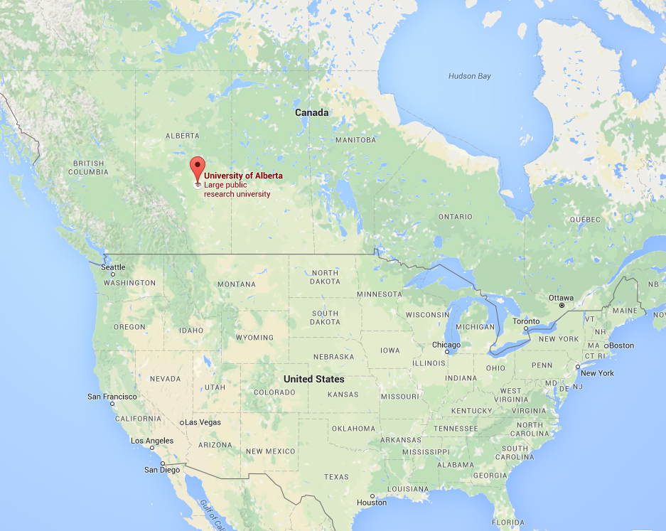
US News Ranking:  #4 (Canada) | CGPA Requirements:  Requirements |  |  | Admission Deadlines:  (Varies by major)
English Proficiency:  TOEFL – 86 (at least 21 for each section)  IELTS – 6.5 (no band less than 5.0)  Cambridge CAE – B  Cambridge CPE – C | Tuition & Fees:  $16,000 - $18,000 |  |  | Location & Setting:  Edmonton, Alberta  (Urban)
Undergraduate Enrollment:  28,200 | Acceptance Rate:  Not reported |  |  | Personal Statement:  N/A
Application Methods:  Online Application | SAT or ACT:  Not reported |  |  | Scholarships Available:  Available
Getting to University:
- Bicycle
- Car
- Edmonton Transit System

Others:
Website

Equivalency Table:  - University Link |  |  | International Representative:  info@international.ualberta.ca

